**/proc > /sys > /dev**

**/proc: hay còn gọi là pseudo file system**

**/sys: extract data from /proc**

**/dev: extract data from /sys**

**/home: is for the user’s home directories, which includes their work in progress and saved files. In a larger environment thi may even be a network file share so that all computers share a common home directory system.**

/var: which is typically used for system log and data files. A database may store its files in /var/lib/mysql, system logs ussually go under /var/log.

Both /home and /var are good candidates for moving to separate partitions. Because they grow the most and have the most write activity. Other lesser candidates for separate partitions are /tmp and /usr. The former is used for temporary file storage and can often grow, or need to be supported by a faster disk, and the latter can grow over time or may be shared across multiple systems.

/boot: this is a small partition used to contain files necessary for loading the kernel.

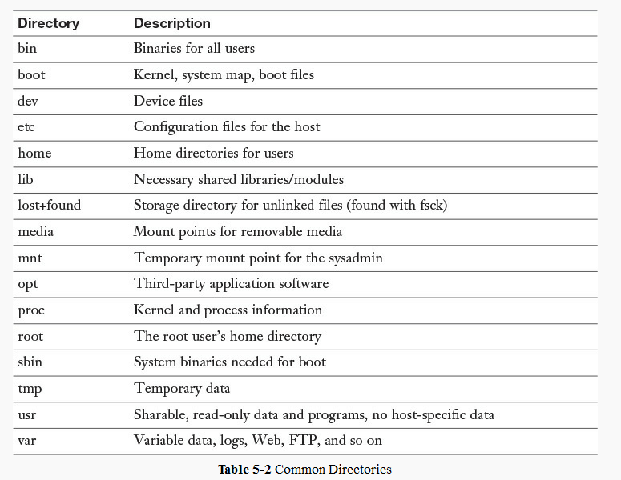

**Filesystem Hierarchy Standard**

By placing files in the same general place across Linux distributions, the FHS simplifies distribution-independent software development. The FHS is also used in the Linux Standard Base. The FHS allows both users and software to predict the location of installed files and directories. An FHS-compliant filesystem assumes that the operating system supports the basic security features found in most UNIX filesystems.

**The two independent FHS categories**

At the core of the FHS are two independent characteristics of files:

**Shareable vs. unshareable**

Shareable files can be located on one system and used on another, while unshareable files must reside on the system on which they are used.

**Static vs. variable**

Static files change only through system administrator intervention, such as installing or upgrading a package, and include documentation, libraries, and binaries. Variable files are all other files, such as logs, spool files, databases, and user data, which are subject to change by users and by system processes.

These distinctions allow files with different sets of characteristics to be stored on different filesystems. Table 1 is an example from the FHS document showing a layout that would be FHS-compliant.

**Table 1. FHS example**

|  | **Shareable** | **Unshareable** |
| --- | --- | --- |
| **Static** | /usr /opt | /etc /boot |
| **Variable** | /var/mail /var/spool/news | /var/run /var/lock |